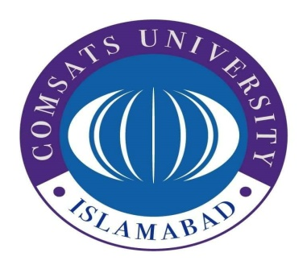

**COMSATS Institute of Information Technology**

**Department of Computer Science, Attock Campus**

**“MAD”**

**“ ASSIGNMENT 04”**

**NAME:IQRA BAKHTAWAR**

**REG NO: SP20-BSE-033**

**PROGRAM: BS(SE)-VI**

**COURSE INSTRUCTOR: Sir Muhammad Kamran**

**Date: 5-January-2023**

**OUTPUT:**

